SITE VISIT ASSIGNMENT (Jain Center of Southern California [JCSC])
Rel St. 110w
20 points; upload by Thursday 11/18

When: Sunday, November 7; Approx. 5:00–6:30pm (plan to arrive by 4:50pm)
Address: 8072 Commonwealth Ave, Buena Park, CA 90621-2520
Parking is to the left of the temple. There should not be many people there at the time of our visit. I’ll plan to be there at 4:40 and stand by the parking entrance.

Parking should be right here on this side of the building. 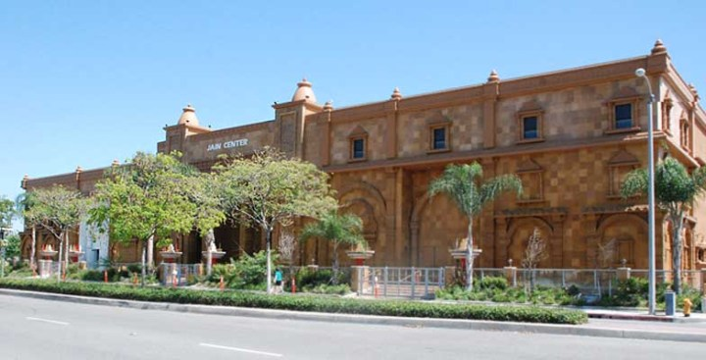

Etiquette Tips:
- Plan to arrive by 4:50pm
- Know that you will be warmly welcome by hosts who are glad to have you visit
- The Jain greeting is “Jai Jinendra” (meaning “Victory to the Jina in You”) with a palms together bow at chest/neck level
- Please bring a notebook and pen to take notes if you like
- Do not take any photos without first asking a host; we will get one photo as a group
- You will be removing shoes; socks are okay
- No meat, alcohol, or other drugs
- Avoid leather belts, shoes and bags if possible, or leave all of them in the shoe closet
- Please dress modestly with full coverage, avoiding bold logos
- When sitting, sit comfortably and attentively without extending feet or laying down; moving around to change positions is perfectly fine

Site visit reflection: After our visit JCSC, write a one-page, single-spaced reflection; upload by Thursday 11/18 [session 9b]

Students will write a one-page, single-spaced reflection after this visit, answering the following question: If you were going to return for fieldwork research at the Jain Center of Southern California, what phenomena (anything you see or are interested in regarding objects or images, ritual, architecture, doctrine, interior landscapes, organizational forms, or patterns of behavior), would you want to study more, why would you want to study it, and what method/s do you feel would be most useful and why?
No works cited is needed, though any direct quotes, paraphrases, or key ideas from texts should be cited with in-text citations or signal phrases, such as “According to Geaves. . . ” (110).; or (Geaves 110).

