Jain Animal Shelters: 3 Perspectives

1
The Jain Bird Hospital in Delhi
by William Meredith (1919-2007)

Outside the hotel window, unenlightened pigeons
weave and dive like Stukas on their prey,
apparently some tiny insect brother.
(In India, the attainment of nonviolence
is considered a proper goal for human beings.)
If one of the pigeons should fly into the illusion

of my window and survive (the body is no illusion
when it’s hurt) he could be taken across town to the bird
hospital where Jains, skilled medical men,
repair the feathery sick and broken victims.
There, in reproof of violence
and of nothing else, live Mahavira’s brothers and sisters.

To this small, gentle order of monks and nuns
it is bright Vishnu and dark Shiva who are illusion.
They trust in faith, cognition, and nonviolence
to release them from rebirth. They think that birds
and animals—like us, some predators, some prey— should be ministered to no less than men and women.

The Jains who deal with creatures (and with laymen)
wear white, while their more enterprising hermit brothers
walk naked and are called the sky-clad. Jains pray
to no deity, human kindness being their sole illusion.
Mahavira and those twenty-three other airy creatures
who turned to saints with him, preached the doctrine of ahimsa,

which in our belligerent tongue becomes nonviolence.
It’s not a doctrine congenial to snarers and poultrymen,
who every day bring to market maimed pheasants.
Numbers of these are brought in by the Jain brothers
and brought, to grow back wing-tips and illusions,
to one of the hospitals succoring such small quarry.

When strong and feathered again, the lucky victims
get reborn on Sunday mornings to the world’s violence,
released from the roofs of these temples to illusion.
It is hard for a westerner to speak about men and women
like these, who call the birds of the air brothers.
We recall the embarrassed fanfare for Francis and his flock.

We’re poor forked sky-clad things ourselves
and God knows prey to illusion e.g., I claim these brothers
and sisters in India, stemming a little violence, among birds.

William Meredith, “The Jain Bird Hospital in New Delhi” from Effort at Speech: New and Selected Poems. Copyright © 1997 by William Meredith. Reprinted with the permission of the author and TriQuarterly Books/Northwestern University Press, http://nupress.northwestern.edu.

______________________________________________________________________
2
A Perspective on Panjrapoles (Animal Shelters) of India
Brett Evans (bevans8@elon.edu)
Elon University, North Carolina, USA
During my undergraduate education, I researched Jainism as part of the Elon College Fellows and Lumen Scholars programs at Elon University in North Carolina (www.elon.edu). As a vegan, I became interested in Jainism primarily due to its impressive and longstanding commitments to nonviolence, vegetarianism, andpanjrapoles (animal homes).
With the assistance of Pravin K. Shah, I involved myself in 2010 with the Jain Study Center of North Carolina, where I attended monthly meetings and conducted interviews with its members. My culminating paper on this research focused on North American Jain involvement with environmental and animal rights movements and has since been published in The Journal for Undergraduate Ethnography (Volume 2 – Issue 2 – June 2012) (http://tinyurl.com/cpx2lnc).
Later, I studied abroad twice in India: the first time in 2011 with the International Summer School for Jain Studies (ISSJS) in North India run by Dr. Shugan Jain, and the second in 2012 with the anthropology-oriented South India Term Abroad (SITA) in Tamil Nadu.
Collectively, and especially living with a Jain family for four months, these experiences taught me a great deal about Jainism. Following the second study abroad program, I undertook two months of independent research in Gujarat and Mumbai focused on Jain animal activists, with particular emphasis on the supporters of panjrapoles.
In the context of this project, I visited 27 Jain panjrapoles and a number of goshalas (cow homes). I had the opportunity to tour these institutions and interview their managers, trustees, and donors. In total, I discussed panjrapoles with more than 100 Jains who were closely connected to these organizations.
In between my two trips to India, a number of respected Jains living in the US raised concerns to me about the conditions present in panjrapoles today. Many of them noted that while they donate to panjrapoles in India, they are uncertain if these charitable organizations are well-run or truly worthy of their support. These individuals had heard many negative reports about panjrapoles, and they hoped that I might be able to shed some light on the situation.
Although assessing the value of these institutions was not the aim of my research project, I agreed to give my honest perspective on panjrapoles when I returned. I agreed because, like you, I am passionate about animal welfare and helping to create a less violent world.
In this spirit, and based upon the experiences of my research field work, I offer you my perspective here. It is my hope that this essay may start a conversation about panjrapoles and how our personal choices may lead to animals being abandoned and slaughtered. If my perspective is incomplete or causes unintentional harm, micchami dukkadam.
As you are likely aware, there is much that is admirable about panjrapoles and the individuals who are involved with them. Historians can trace the presence of animal homes in India for thousands of years, while westerners have had similar sanctuaries for mere decades.
This longevity exhibits the relevance and importance of these institutions in a time of unprecedented slaughter and mistreatment of animals. Such a rich tradition, then, has much to teach those around the world who are involved with contemporary animal rights and welfare movements. Over its long history, many Jains have devoted their human lives to saving and improving animal lives, and even today I did not meet a single panjrapole trustee who was not undoubtedly committed to the cause of protecting life. Indeed, many spent significant amounts of time away from their families and businesses to ensure their charitable work was done.
During my time in India, I was continually impressed and humbled by these individuals. These supporters are faced with a very challenging situation, however, and many, including me, would argue that panjrapoles need improvement and cannot be the only solution to animal suffering.
I would like to pose a broad but crucial question: what is the purpose of a panjrapole? While this query may seem elementary, I believe it is essential that we take a step back in order to chart a way forward. The most common answer I heard to this question is that a panjrapole’s purpose is to protect animals who would otherwise be abandoned or slaughtered.
However, if this is the purpose of the panjrapole, we must ask why animals are being abandoned and slaughtered in the first place. There is a clear answer to this question, and it is readily apparent upon visiting most panjrapoles.
Overwhelmingly, animals living in these institutions are older female cows who are no longer able to produce milk and male calves (who obviously do not have the capacity to produce milk). These animals have been deemed “useless” because they are not profitable to the dairy industry. Neither the dairy industry nor the independent farmer can afford to maintain these unprofitable animals and, as a result, they are abandoned or shipped illegally for slaughter in Maharashtra.
Given this situation, the panjrapole serves as one important solution. However, it is only a temporary, stop-gap solution. If we regard panjrapoles as a permanent solution, then they (and we) are simply enabling a system that produces the injustice of abandoned and slaughtered animals, and the milk producers continue to profit at the expense of the panjrapoles, who bear the burden of taking in the old females and young males.
This “solution,” which effectively redistributes rather than reduces dairy’s violent outcomes to panjrapoles, is neither sustainable nor equitable. Moreover, it is widely acknowledged by panjrapole supporters that these institutions are only able to take in a tiny percentage of the animals in need. This lack of housing capacity is obvious when you consider the amount of milk products consumed in India. It would be impossible for panjrapoles to house the hundreds of millions of cattle and buffaloes who produce milk across the country.
We must remember that half of this number, the male population, is cast aside immediately and that young, lactating females naturally would be outnumbered by their older, “unproductive” counterparts. And, these figures do not even include goats, sheep, birds, dogs, cats, and the rest of animals in need who are not used for mainstream dairy but are currently minority residents of panjrapoles.
As it is, most of the panjrapoles I visited were incredibly overcrowded. Many of these panjrapoles were originally built on grazing grounds outside of cities, but, as these metropolises developed, the animal homes were eventually swallowed by them. Urban expansion means that panjrapoles are now located in confined, polluted environments that are not well-suited to animals.
While many managers and trustees admit this is a problem, most stated it is not financially feasible to relocate. Few panjrapoles can afford to provide any space for animals to roam or graze, which means that the animals in these shelters typically have an unnatural and poor quality of life—one which is better than starvation or slaughter but not one which we would find an acceptable, systemic outcome for countless individuals.
It is with the circumstances that I have outlined above in mind that I advocate for a permanent solution that strikes at the root of the problem panjrapoles are intended to address.
This solution is surely familiar to many of you:
It is to adopt a Vegan (strict or pure vegetarian) Lifestyle.
By choosing to be strict vegetarian and not consume dairy products, you are ensuring that the demand for milk falls and thus less milk will be produced. When industry produces less milk, fewer young male and older female cows will be bred, and subsequently abandoned or sent for slaughter, and fewer animals will need to be housed in panjrapoles.
This nonviolent action moves us toward a sustainable and equitable solution that will one day allow panjrapoles to dedicate their resources towards truly needy and injured animals. As long as we consume non-human dairy, something will need to be done with the young males and older females who are deemed “useless” because they have no role in the production process. Panjrapoles alone cannot be the answer.
There are too many animals in need, and too few panjrapoles. Please consider veganism. This practice avoids the violence inherent in dairy and is very closely aligned with the core Jain tenets of ahimsa, jiv-daya (compassion for life), and parasparopagraho jivanam (all life is bound together by mutual support and interdependence).
I sincerely hope we can have an honest discussion about the linkages between dairy, violence, and panjrapoles. We should not let our choices require animals to end up in overcrowded and unsustainable panjrapoles or worse. If you have any comments or suggestions, feel free to e-mail me.
If my perspective causes unintentional harm, micchami dukkadam.
Brett Evans (bevans8@elon.edu)
Elon Community Garden and Loy Farm Manager
Office of the University Registrar, Research Assistant
Elon University, North Carolina, USA
July 14, 2013
_______________________________________________________________________

3

Thursday, April 02, 2009

The Jain Bird Hospital/Anti-Euthanasia Center in Delhi

Lonnie Bruner Blog

http://lonniebruner.blogspot.com/search?q=Jain+Bird+Hospital

Yesterday I went to the Jain temple and bird hospital in Delhi, India. Jains are extreme pacifists. They eat no animals, believe every living creature has a soul, and the monks and nuns sweep the ground in front of them as they walk to prevent stepping on and killing insects.
Many living creatures in Delhi are mangled to some degree or other -- even the people. The streets have no shortage of limping dogs with open sores, skinny cows and horses, and a few grubby beggar children.
So the Jains have an entire hospital devoted to caring for the injured and infected birds -- mostly pigeons. We walked into the clinic to many odd paintings depicting the various dangers that befall the birds of India:
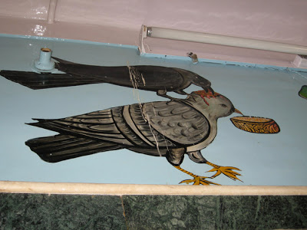
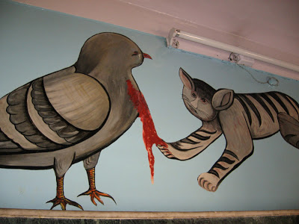
The walls were lined with stacked cages of injured pigeons, some with bird-sized casts on their wings. Many of these animals were in TERRIBLE shape -- shivering in small cages, or with pus-filled infections. See, this is the problem with religion: they are so driven by their dogma that no animal should be killed, that they do not see the obvious ethical problem of allowing suffering animals to go on living without the benefit of euthanasia. Even PETA euthanizes suffering animals.
I won't post pictures of the worst-looking birds, but here are a few we saw at this weird place. All in all, there were thousands of (mostly) pigeons at this place. They told us that they receive about 150 hurt birds a day:
Pigeon with a bandage on its wing:
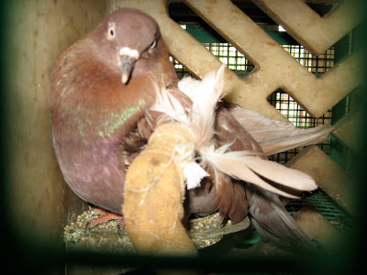
The only peahen at the Center. They said some kids had thrown stones and broke its wing:
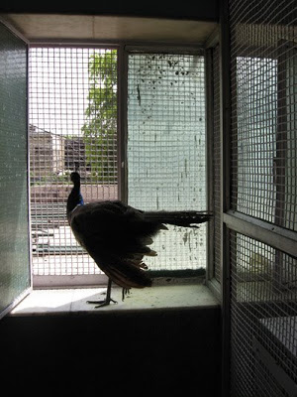
There were lots of pigeons with wing bandages:
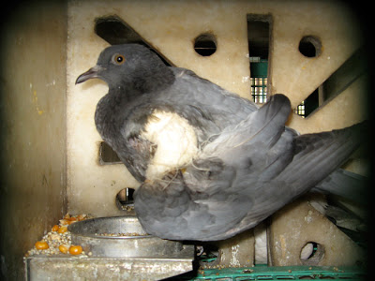
A view from the roof of the Jain bird hospital. They release hundreds of recovered birds per day:

